Registration No.- 19BCE2119

Name-Gaurav Kumar Singh

Slot- L-13+L-14

Title- Cement Industry Project Management

Mobile Number- 9664395951

**Review-2**

**CEMENT INDUSTRY PROJECT MANAGEMENT DATABASE**

Cement Manufacturing is the infrastructure of establishing many other infrastructures. As important as it is, its also a very complex process to manufacture cement. Sourcing and mining of limestone and other ores, clinker manufacturing, to mixing and packaging, a lot of raw materials, sourcing and machineries are involved. Because of all this the units and projects have to established in several different parts of the country or even world and to keep track of everything can often get confusing but also plays important role since everything is unit plays an important role for the manufacturing process. To reduce this confusion, DBMS can be used to reduce overall complexity and make it easier and faster for us to access the data when needed, increasing our overall efficiency.

**ENTITY-RELATIONSHIP DIAGRAM**

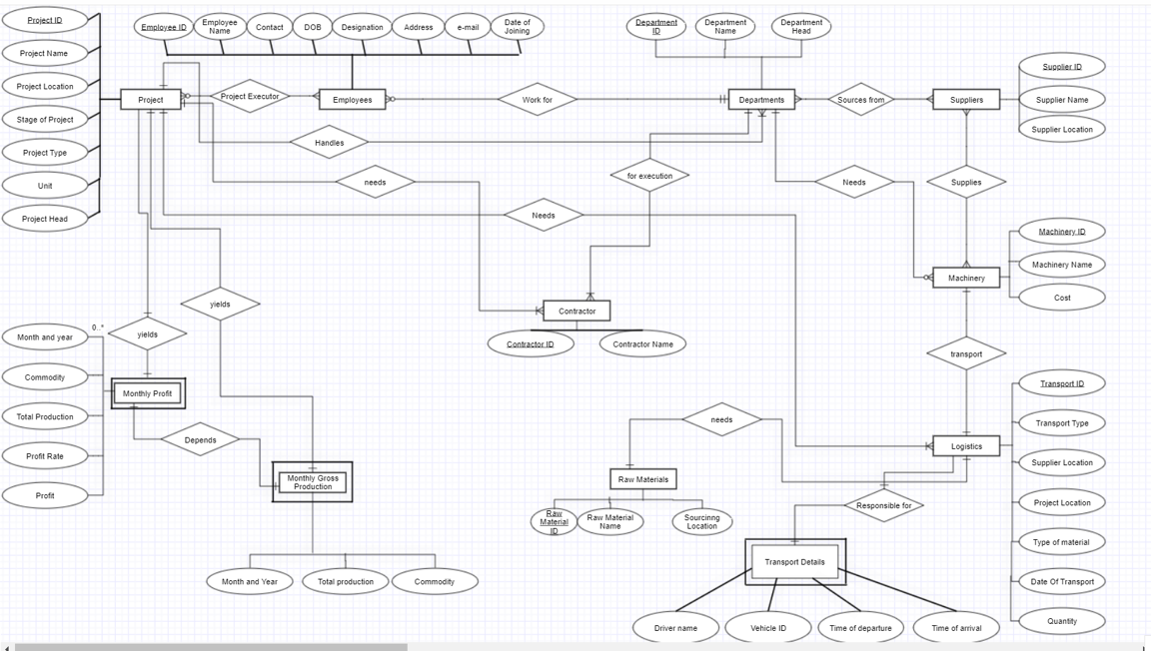

**CONCEPTUAL SCHEMA**

**PROJECT**

Project_ID, Project_Name, Project_Location, Stage_of_Project, Project_Type, Unit, Project_Head

**EMPLOYEES**

Emp_ID, Emp_Name, Contact, DOB, Designation, Address, E-mail, Date_of_Joining, Project_ID, Dept_ID

**DEPARTMENTS**

Dept_ID, Dept_Name, Dept_Head, Project_ID

**SUPPLIERS**

Supplier_ID, Supplier_Name, Supplier Location

**MACHINERY**

Machinery_ID, Machinery_Name, Cost, Supplier_ID

**RAW MATERIALS**

Raw_Material_ID, Raw_Material_Name, Unit, Cost per unit

**LOGISTICS**

Tran_ID, Trans_Type, From, To, Mat_ID, Quantity

**CONTRACTOR**

Contractor_ID, Contractor_Name, Project_ID, Dept_ID

**MONTHLY PROFIT**

Month_and_Year, Project_ID, Commodity, Total_Production, Profit_Rate, Profit

**TRANSPORT DETAILS**

Driver_Name, Vehicle_ID, Date_and_Time_of_Departure, Date_and_Time_of_Arrival, Trans_ID

**NORMALIZATION**

**Original Employees Table**

|  |  |  |  |  |  |  |  |  |  |
| --- | --- | --- | --- | --- | --- | --- | --- | --- | --- |
| Employees | | | | | | | | | |
| Emp  ID | Emp  Name | Contact | Date of birth | Designation | Address | E-mail | Date of joining | Project  ID | Dept  ID |
| 1 | Ajay | 99999 | 01-Jan-1994 | DGM | A-192 | ajay@iti.com | 21-Feb-2020 | P0001  P0002 | DP1 |
| 2 | Bhola | 88888 | 02-Mar-1992 | GM | B-143 | bhola@iti.com | 22-March-2018 | P0001 | DP2 |
| 3 | Chris | 77777 | 03-May-1900 | Add.GM | C-150 | chris@iti.com | 23-Dec-2015 | P0002  P0003 | DP1 |

**1NF**

**Functional Dependency:**

Emp ID 🡪 Emp Name, Contact, Date of Birth, Address, E-mail, Date of Joining, Dept ID

Project ID🡪 Project ID

Contact 🡪 Emp ID

E-mail 🡪 Emp ID

Emp ID, Project ID 🡪 R

**Candidate Key:** Emp ID, Project ID

In order for a table to be in 1NF:

1. It should have atomic attributes only.
2. Each column must have unique names.
3. Order of the entries does not matter.
4. Each column must contain values of same variable type.

|  |  |  |  |  |  |  |  |  |  |
| --- | --- | --- | --- | --- | --- | --- | --- | --- | --- |
| Employees | | | | | | | | | |
| Emp  ID | Emp  Name | Contact | Date of birth | Designation | Address | E-mail | Date of joining | Project  ID | Dept  ID |
| 1 | Ajay | 99999 | 01-Jan-1994 | DGM | A-192 | ajay@iti.com | 21-Feb-2020 | P0001 | DP1 |
| 1 | Ajay | 99999 | 01-Jan-1994 | DGM | A-192 | ajay@iti.com | 21-Feb-2020 | P0002 | DP1 |
| 2 | Bhola | 88888 | 02-Mar-1992 | GM | B-143 | bhola@iti.com | 22-March-2018 | P0001 | DP2 |
| 3 | Chris | 77777 | 03-May-1900 | Add.GM | C-150 | chris@iti.com | 23-Dec-2015 | P0002 | DP1 |
| 3 | Chris | 77777 | 03-May-1900 | Add.GM | C-150 | chris@iti.com | 23-Dec-2015 | P0003 | DP1 |

**2NF**

In order for a table to be in 2NF form:

1. It should be in 1NF form.
2. It should not have any partial dependencies.

Candidate key: Emp ID

|  |  |  |  |  |  |  |  |  |
| --- | --- | --- | --- | --- | --- | --- | --- | --- |
| Employees | | | | | | | | |
| Emp  ID | Emp  Name | Contact | Date of birth | Designation | Address | E-mail | Date of joining | Dept  ID |
| 1 | Ajay | 99999 | 01-Jan-1994 | DGM | A-192 | ajay@iti.com | 21-Feb-2020 | DP1 |
| 2 | Bhola | 88888 | 02-Mar-1992 | GM | B-143 | bhola@iti.com | 22-March-2018 | DP2 |
| 3 | Chris | 77777 | 03-May-1900 | Add.GM | C-150 | chris@iti.com | 23-Dec-2015 | DP1 |

Candidate key: Emp ID, Project ID

|  |  |
| --- | --- |
| Employee’s Ongoing Project | |
| Emp ID | Project ID |
| 1 | P0001 |
| 1 | P0002 |
| 2 | P0001 |
| 3 | P0002 |
| 3 | P0003 |

The decomposition is lossless because:

1. Attributes(r1) U Attributes(r2) = Attributes(R) {R}
2. Attributes(r1) ∩ Attributes(r2) != null {Emp ID}
3. Attributes(r1) ∩ Attributes(r2) 🡪 r1 {Emp ID🡪Employees}

Where,

r1: Employees table after decomposition

r2: Employee’s Ongoing Project table

R: Employees table before decomposition

**3NF**

In order for a table to be in 3NF form:

1. It should be in 2NF form.
2. It should not have any transitive dependency.

Candidate key: Emp ID

|  |  |  |  |  |  |  |  |  |
| --- | --- | --- | --- | --- | --- | --- | --- | --- |
| Employees | | | | | | | | |
| Emp  ID | Emp  Name | Contact | Date of birth | Designation | Address | E-mail | Date of joining | Dept  ID |
| 1 | Ajay | 99999 | 01-Jan-1994 | DGM | A-192 | ajay@iti.com | 21-Feb-2020 | DP1 |
| 2 | Bhola | 88888 | 02-Mar-1992 | GM | B-143 | bhola@iti.com | 22-March-2018 | DP2 |
| 3 | Chris | 77777 | 03-May-1900 | Add.GM | C-150 | chris@iti.com | 23-Dec-2015 | DP1 |

Candidate Key: Emp ID, Project ID

|  |  |
| --- | --- |
| Employee’s Ongoing Project | |
| Emp ID | Project ID |
| 1 | P0001 |
| 1 | P0002 |
| 2 | P0001 |
| 3 | P0002 |
| 3 | P0003 |

**BCNF**

In order for a table to be in BCNF (also known as 3.5NF) form:

1. It should be in 3NF form.
2. No non-prime attribute must be able to derive a prime attribute i.e.

For a relation A🡪B, B cannot be prime attribute if A is a non-prime attribute

Candidate Key: Emp ID

|  |  |  |  |  |  |  |
| --- | --- | --- | --- | --- | --- | --- |
| Employees | | | | | | |
| Emp  ID | Emp  Name | Date of birth | Designation | Address | Date of joining | Dept  ID |
| 1 | Ajay | 01-Jan-1994 | DGM | A-192 | 21-Feb-2020 | DP1 |
| 2 | Bhola | 02-Mar-1992 | GM | B-143 | 22-March-2018 | DP2 |
| 3 | Chris | 03-May-1900 | Add.GM | C-150 | 23-Dec-2015 | DP1 |

Candidate Key: Emp ID, Project ID

|  |  |
| --- | --- |
| Employee’s Ongoing Project | |
| Emp ID | Project ID |
| 1 | P0001 |
| 1 | P0002 |
| 2 | P0001 |
| 3 | P0002 |
| 3 | P0003 |

Candidate Key: Emp ID

|  |  |  |
| --- | --- | --- |
| Employee Contact Details | | |
| Emp Id | Contact No. | Email ID |
| 1 | 99999 | ajay@iti.com |
| 2 | 88888 | bhola@iti.com |
| 3 | 77777 | chris@iti.com |

The decomposition is lossless because:

1. Attributes(r1) U Attributes(r2) = Attributes(R) {R}
2. Attributes(r1) ∩ Attributes(r2) != null {Emp ID}
3. Attributes(r1) ∩ Attributes(r2) 🡪 r1 {Emp ID🡪Employees,

Emp ID 🡪Employee Contact Details}

Where,

r1: Employees table after decomposition

r2: Employee Contact Details table

R: Employees table before decomposition

**Database Schema in BCNF**

|  |  |  |  |  |  |  |
| --- | --- | --- | --- | --- | --- | --- |
| Project | | | | | | |
| Project ID | Project Name | Project Location | Stage of Project | Project Type | Unit | Project Head |

|  |  |  |  |  |  |  |
| --- | --- | --- | --- | --- | --- | --- |
| Employees | | | | | | |
| Emp  ID | Emp  Name | Date of birth | Designation | Address | Date of joining | Dept  ID |

|  |  |
| --- | --- |
| Employee’s Ongoing Project | |
| Emp ID | Project ID |

|  |  |  |
| --- | --- | --- |
| Employee Contact Details | | |
| Emp Id | Contact No. | Email ID |

|  |  |
| --- | --- |
| Departments | |
| Department ID | Department Name |

|  |  |  |
| --- | --- | --- |
| Head and Department Relation | | |
| DID | Department ID | Department Head |

|  |  |
| --- | --- |
| Project Departments’ Head | |
| Project ID | DID |

|  |  |
| --- | --- |
| Supplier Names | |
| Supplier ID | Supplier Name |

|  |  |
| --- | --- |
| Supplier’s Location | |
| Supplier ID | Location |

|  |  |
| --- | --- |
| Machinery | |
| Machinery ID | Machinery Name |

|  |  |  |
| --- | --- | --- |
| Machinery Cost | | |
| Machinery ID | Supplier ID | Cost |

|  |  |
| --- | --- |
| Raw Material | |
| Raw Material ID | Raw Material Name |

|  |  |  |
| --- | --- | --- |
| Raw Material Costing | | |
| Raw Material ID | Unit of Measurement | Cost per unit |

|  |  |  |  |  |  |
| --- | --- | --- | --- | --- | --- |
| Logistics | | | | | |
| Transport ID | Transport Type | From | To | Material  ID | Quantity |

|  |  |
| --- | --- |
| Contractor | |
| Contractor ID | Contractor Name |

|  |  |  |
| --- | --- | --- |
| Contracted Field | | |
| Contractor ID | Project ID | Department ID |

|  |  |
| --- | --- |
| Commodity Produced | |
| Project ID | Commodity |

|  |  |  |  |
| --- | --- | --- | --- |
| Monthly Gross Produce | | | |
| Month and Year | Project ID | Total Production | Profit rate |

|  |  |  |
| --- | --- | --- |
| Profit | | |
| Total Production | Profit Rate | Profit |

|  |  |  |  |  |
| --- | --- | --- | --- | --- |
| Transport Details | | | | |
| Transport ID | Vehicle ID | Date of Departure | Date of Arrival | Driver/Operator |